**Standard fit**

k1 = 0.8232, k2 = 0.3447, k3 = 0.6515, k4 = 0.2155, k5 = 0.9962, k6 = 0.3109

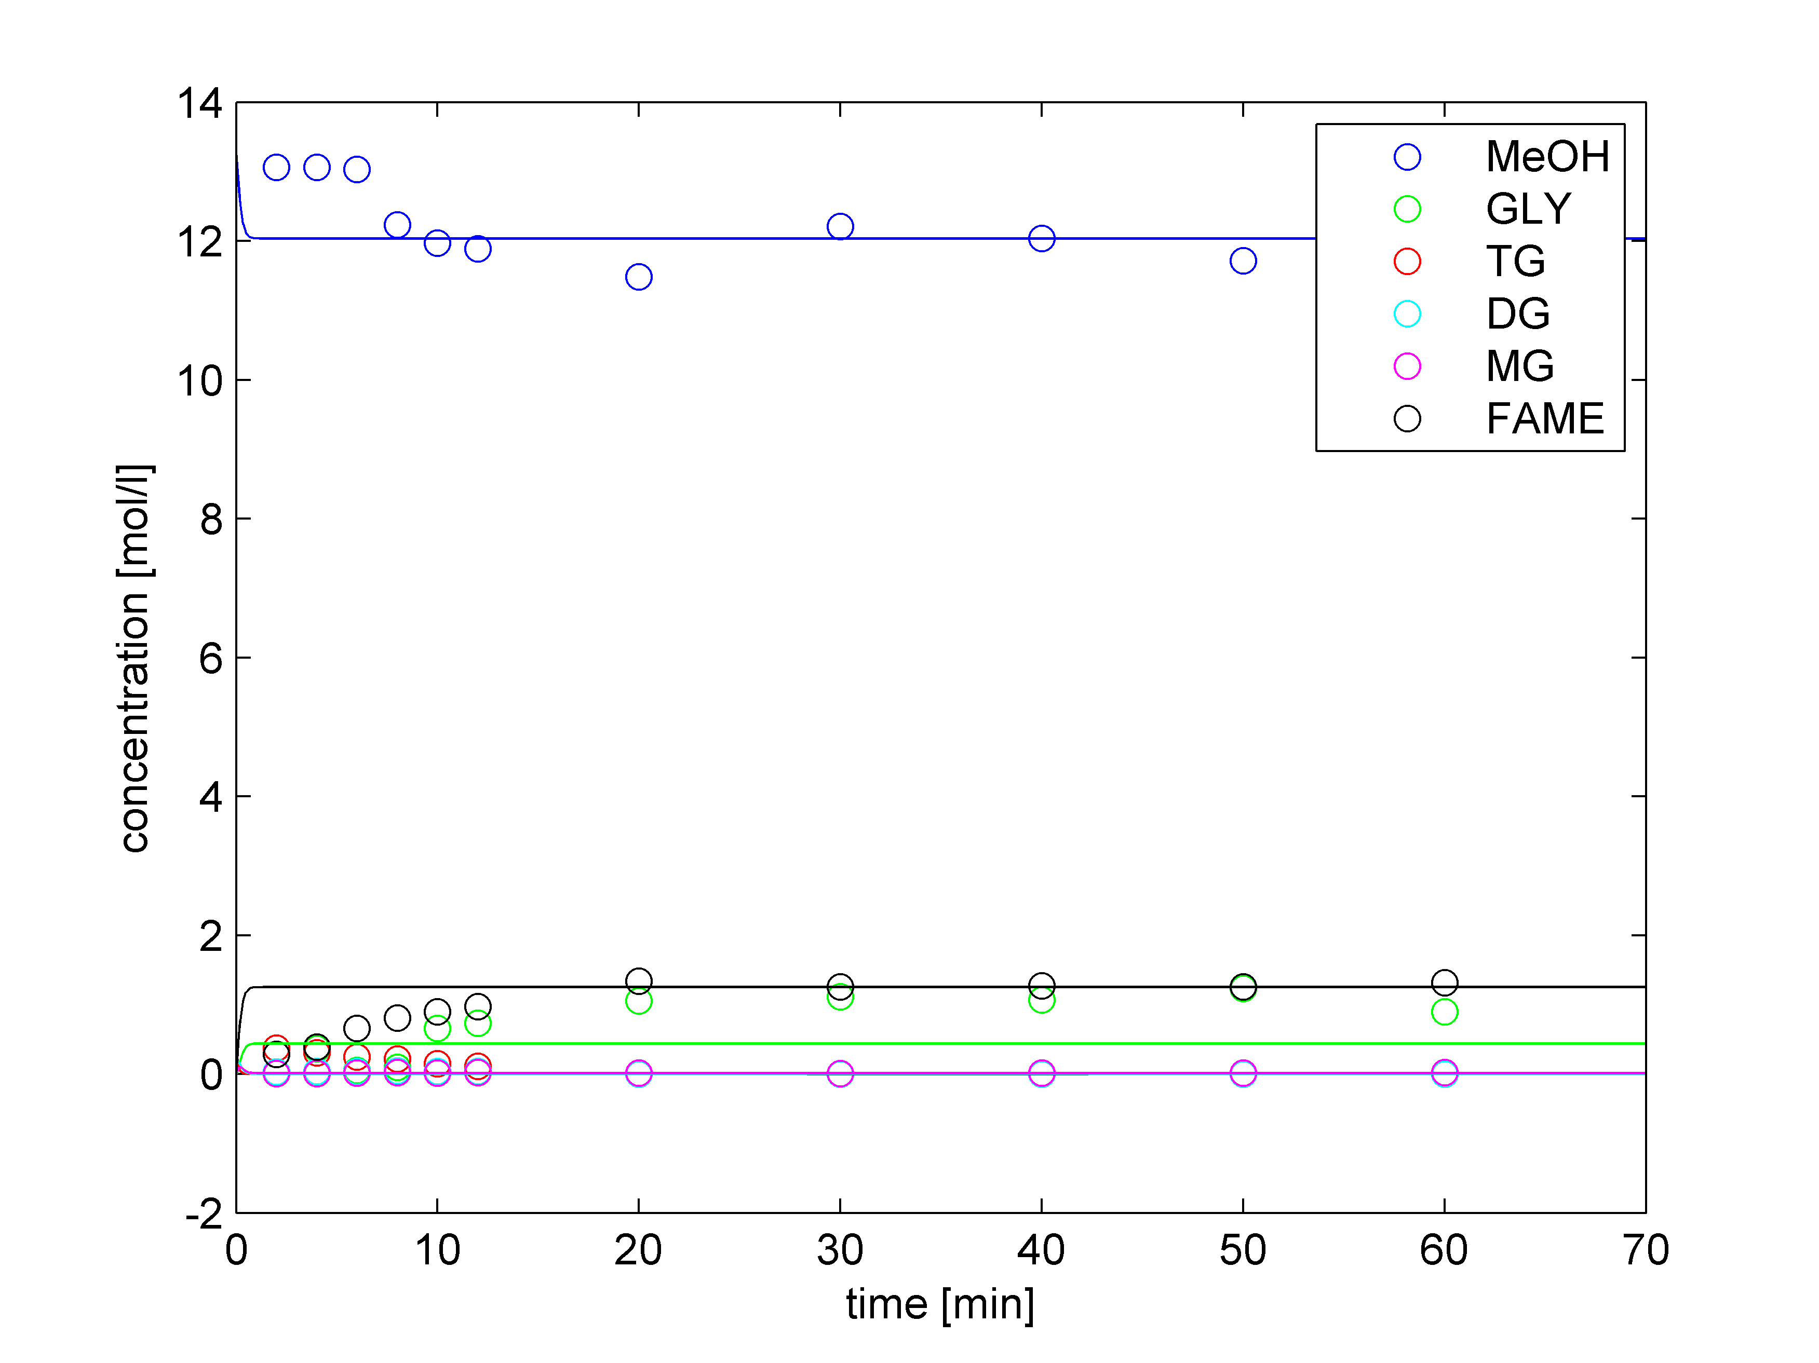

**Regularized fit**

k1 = 0.0154, k2 = 0.1353, k3 = 0.0718, k4 = 0.0219, k5 = 0.2053, k6 = 0.0996

